**INVENTORY ASSIGNMENT**

Using Functionality

1. Web Api
2. Asp.net MVC
3. Visual Studio 2019

Database : SQL SERVER DATABASE

Frontend : HTML, CSS, JAVASCRIPT

Backend : C#

Now. We are build a web site for small activity Like Data Add, Save, Edit and Delete.We are taken Sql Server Database which are present in VB.Net 2019 for store data which added and deleted by the user.

Inside this Project there are two project added for one as Inventory WEB API and second as Inventory MVC.

When user getting this web page then he perform according to button activity where he does save data in database also some data are wrong then edit option also there for change data.

Main Form ScreenShot:

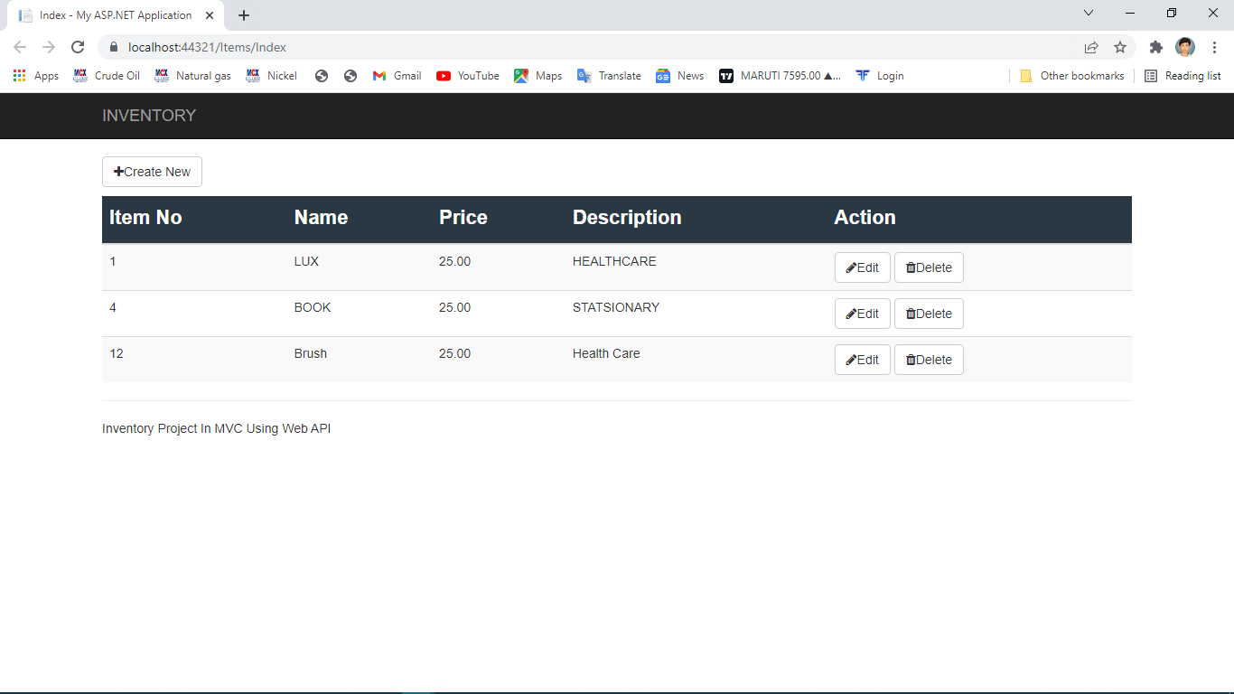

Data Edit ScreenShot:

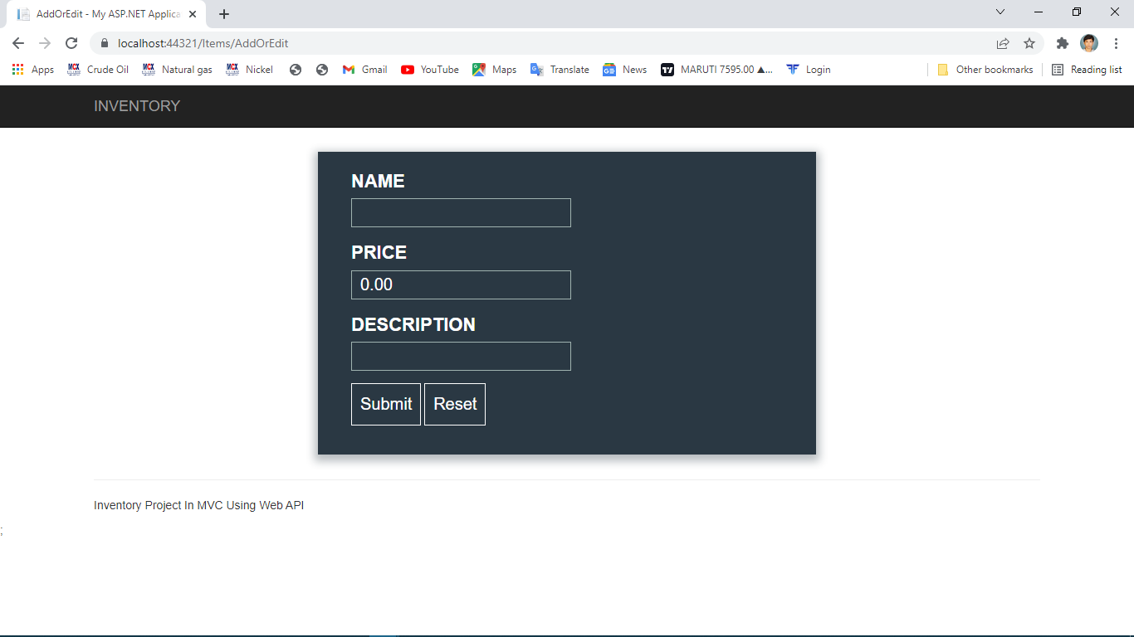

Database Name DBINVENTORY.mdf

Query for create table

Create table Item

(

ITEM_NO INT PRIMARY KEY IDENTITY(1,1),

ITEM_NAME NVARCHAR(150) NOT NULL,

ITEM_PRICE NUMERIC(18,0) NOT NULL,

ITEM_DESCRIPTION NVARCHAR(150) NOT NULL

)

INSERT INTO ITEM(ITEM_NAME,ITEM_PRICE,ITEM_DESCRIPTION) VALUES(‘SOUP’,25,’HEALTH CARE’)

INSERT INTO ITEM(ITEM_NAME,ITEM_PRICE,ITEM_DESCRIPTION) VALUES(‘BRUSH’,20,’HEALTH CARE’)

INSERT INTO ITEM(ITEM_NAME,ITEM_PRICE,ITEM_DESCRIPTION) VALUES(‘GEMINI OIL’,155,’FOOD’)

INSERT INTO ITEM(ITEM_NAME,ITEM_PRICE,ITEM_DESCRIPTION) VALUES(‘SUGAR’,46,’FOOD’)

INSERT INTO ITEM(ITEM_NAME,ITEM_PRICE,ITEM_DESCRIPTION) VALUES(‘BOOK’,50,’STATIONARY’)

SELECT * FROM ITEM;